FOR IMMEDIATE RELEASE
CONTACT: Chuck Bagby, 210-445-7319, cbagby@BurningHeartBibleStudies.com

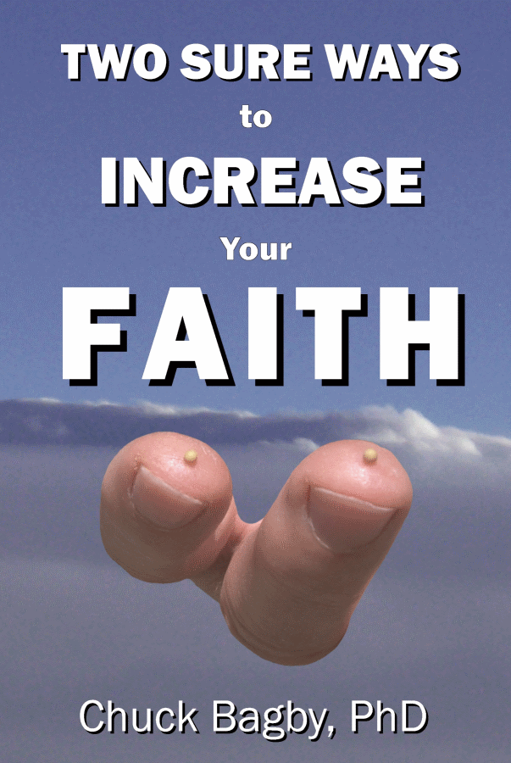

Book Reveals the Secret to Increasing Faith

SAN ANTONIO, TX — April 1, 2018 — Burning Heart Bible Studies announces the release of Two Sure Ways to Increase Your Faith, a book that explains how to strengthen faith by boosting two dynamic factors.

In Two Sure Ways to Increase Your Faith, ($10.99, Burning Heart Bible Studies, January 2018) author Chuck Bagby examines the nature of the faith God desires His followers to possess and explains how to develop the necessary fundamentals to increase your own faith.

Two Sure Ways to Increase Your Faith reveals how spiritual heroes in the Scriptures cultivated strong faith and how you, too, can advance your faith beyond the ordinary.

“Most conventional writings either employ a style too academic for mainstream Christians to digest or present material too shallow to nourish the spirit,” says Bagby. “In contrast, Two Sure Ways to Increase Your Faith digs deeply enough to uncover the essentials of faith, yet speaks clearly enough for a novice to understand.”

Bagby holds a doctorate in biblical studies from the Theological University of America. He worked fulltime as an evangelist for ten years, completing foreign assignments in Honduras and Argentina. Following that, while dedicating two decades to the business world, he continued to “do the work of an evangelist” (2 Timothy 4:5 NASB). He teaches today through Burning Heart Bible Studies books and seminars, while serving as a Consulting Professor of Biblical Studies for NationsUniversity.

Two Sure Ways to Increase Your Faith
($10.99, 205 pages, 6 x 9 inches, paperback, ISBN: 978-0-9911520-3-2)
Available at BurningHeartBibleStudies.com and most booksellers

CONTACT: Chuck Bagby, 210-445-7319, cbagby@BurningHeartBibleStudies.com

Burning Heart Bible Studies produces books and multimedia seminars that address spiritual needs.

# # #

